ICTGAM433

Optimisation

IMMERSIVE STUDIOS

ASSESSMENT 3

Xihao Chen | 30053752

2022

Table of Contents

**No table of contents entries found.**

# Image Render/Time Comparison

|  |
| --- |
| The first test render image result **without** the additional optimisations as outlined in the design brief. The render time (including compositing time) was **1m 54s 94ms (CPU Compute)**, which narrowly satisfies the ≤ 2-minute render time requirement outlined in the design brief. |
| The second test render image result **with** the additional optimisations as outlined in the design brief:   * Converting all procedural textures into baked textures (Rocks, Kermit, Floor, Beam Core) * Change any camera-based textures to geometry-based (Rocks) * Adjustments to light bounces and anti-aliasing settings   The render time (including compositing time) was **0m 39s 64ms (GPU Compute)**, saving ~ 1 minute 14 seconds of rendering time compared to the unoptimised render. Other optimisations include changes to the spotlight position/intensity and light pass settings. |

# Pre-Rendering Optimisations

The following pre-rendering optimisations were performed for the **optimised** test render image:

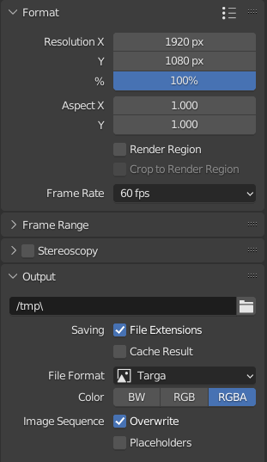

Ensuring the image resolution was 1920x1080.

Setting the output file to TARGA.

## Colour Management Settings

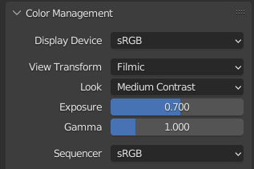

The “Medium Contrast” and reduced exposure/gamma values (0.700 / 1) help reduce the environmental light intensity, saving time/computer resources during rendering as a result.

## Compositing Settings

Denoising effects.

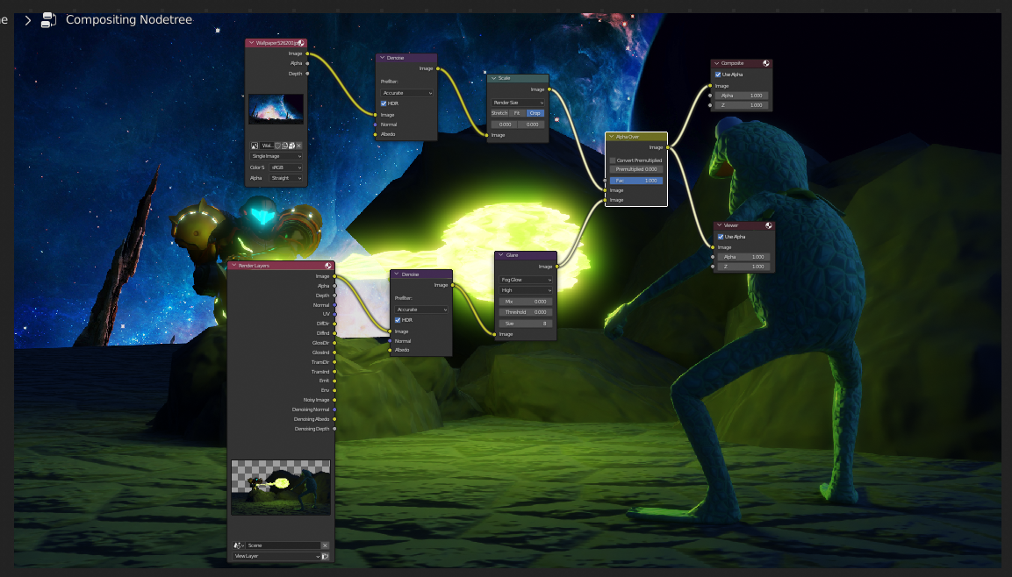

Quality of the “Fog Glow” glare effect set to “High” to improve bloom precision, which improves compositing quality.

## World Lighting Settings

Denoising nodes to eliminate residual noise from source inputs.

Base render result for compositing use.

Background overlay for compositing use.

Glare to simulate “bloom” effect.

Scaling denoised image to fit render dimensions.

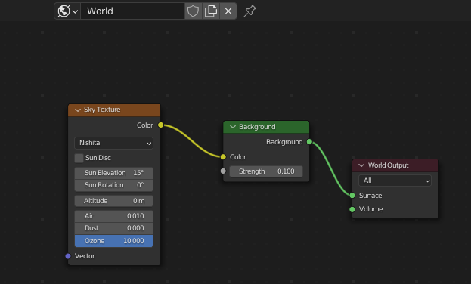

Using the “Nishita” sky texture for simulating world light, allowing for greater control over the intensity/positioning of lighting in the scene.

# Render Settings Optimisations/Changes

The following render settings optimisations/changes were performed for the **optimised** test render image:

## Performance Settings

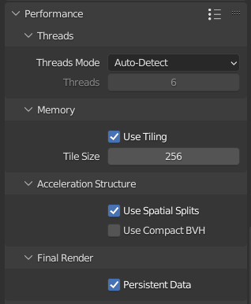

With “GPU Computing” enabled”, a tile size of 256 produced the quickest image rendering times.

“Spacial Splits” and “Persistent Data” are enabled to further speed up image rendering, with a trade-off of increased memory usage during the render.

## Render Layers/Passes

Alpha threshold set to minimum, allowing passes to affect all pixels in the render image.

“Emission” and “Environment” passes to enhance the respective effect’s quality without sacrificing render speed.

Enabling direct/indirect passes for “Diffuse”, “Glossy” and “Transmission” passes to match the light bounce settings.

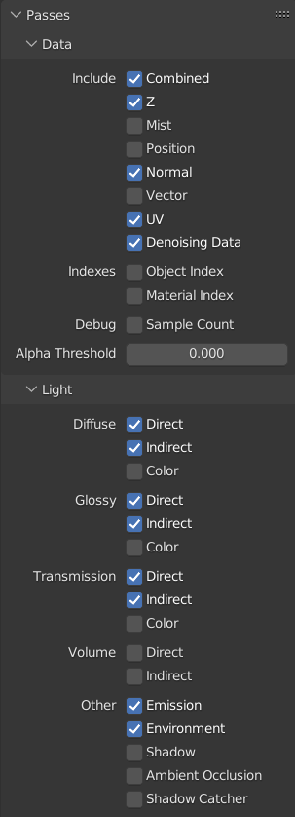

“Normal”, “UV” and “Denoising Data” passes enabled to improve render quality with a small impact on render time.

# File/Folder Organisation

## Backup/Archive Process

# Additional Optimisations

## Procedural Textures to Baked Textures

## Camera-based Textures to Geometry-Based Textures

## Light Bounce/Anti-Aliasing Settings

### Light Paths Settings

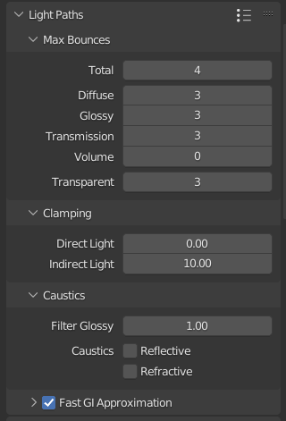

Max light bounces limited to 4, which substantially improves rendering speed without sacrificing image quality.

Clamped maximum indirect light value to 10.00 to reduce the amount of “fireflies” noise artifacts from the rendering process.

Enabled to increase rendering speed.

### Sampling Settings

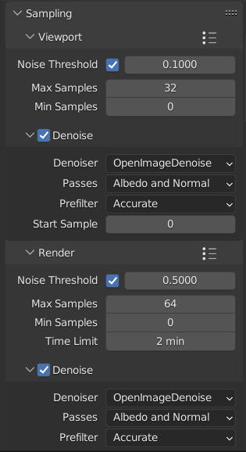

Viewport max samples set to 32 to improve responsiveness while navigating in the 3D viewport. “Denoising“ enabled and “Noise Threshold” set to 0.1 to filter out visible noise.

Render max samples set to 64 for greater visual fidelity while respecting the 2-minute limit on render times. Denoising enabled to reduce noise artifacts during the render process.

### Film (Anti-Aliasing Pixel Filter)

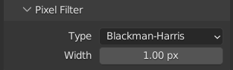

Blackman-Harris filter changed from 1.50 px to 1.00 px for less edge blur/anti-aliasing filtering.